Introduction
Star Loop Academy is an online learning website; it is a business-to-consumer
(B2C) business. Its URL is
https://project.cs.cf.ac.uk/WangK27/Coursework/wordpress/. It sells online learning material, like video within the United Kingdom. The target market is students who would like to learn programming language and improve programming skill. The online learning community will be built in future. Moreover, it offers secure payment through PayPal.
Star Loop Academy has been implemented by the theme called “Menus”. The theme is responsive. In other words, the customers can use the website on various devices such as PC, iPhone and tablet. Therefore, customers are not restricted by place or time; they can use it at home or work, as well as on the road. Also, Star Loop Academy will develop its app based on Android and iOS. According to (ONS), Over 74 percent of web page views were generated via mobile. Namely, the users tend to browse the website using mobile device.
My business starts from online shop, which means our cost will be less than the normal competitors. Kelly O. Cowart Ronald E. Goldsmith(2007) argue that the online shop can reduce consumption for employer due to the rent fees and bills. The public established a company or organisation need oversize capital in infrastructure, such as the lease in densely populated area and the salary for staff. This is advantage for my business in the first stage. However, my company will run a branch next to high school and university in Cardiff, which aim at providing the offline learning centre, customer can buy books and learning material in there. The shop also organise some events for attracting people and building some small programming community for helping our member make friends and find jobs. This is because our competitors provide similar service online, our offline service is good way to develop our brand and stand out from the crowd.

Implementation
Wishlist: it can save the product for customer. It also can share the customers’ wishlist on social media, such as Facebook and Twitter. Alessandor(2014) argue that the social media has profound impact on selling product, such as the share promotion or Wishlist. In other word, customers share their wishlist on their social media and help business expand.

Logo: the logo has been designed for expanding the band name. According to Paul A. Bottomley and John R.Doyle(2006), the colors “red” enhance the effect of brand. This is the one of reasons I set red color on my logo name.

Categories: there are five categories, such as Assembly Language ,Database ,Functional Language ,Logic Language and Scripting Language. It will make customer find the learning material easily.

Material download: the material provided automatically download service.

Coupons: it provides discount for regular customers. You can use the “starloop” for getting discount. Coupons are one of the most important and successful promotional tools today (JUNG, K.2010).

Shopping cart: it can save the product which customers would like to buy.

Search bar: it can search the online material. It provides another way to find specific product for customers.

Register new user: the website allow customer to register their own account, it also provide coupons to encourage customer. According to Grace T.R. Lin (2009), the service assets has a influence on customers’ loyalty.

About page: the page display the address and contact detail of the company, which reassure our customers with satisfaction transparent information and make customers trust our company.

Support page: our company provides help service for customers through support page. Customers can connect with our support team through email.

The below image provide information about the architecture of website:

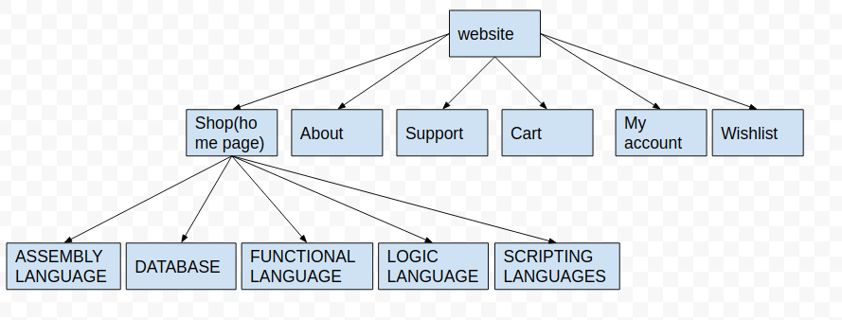
Usability and Security
According to Carole A.George(2005), participants can test the website and share their opinion, which is good way to test usability. The website was evaluated by three participants. Meanwhile, there are some feedback and opinion. For example, the main menu always show on the top of the website, even if customer scroll down the website. the reason for this is that it is convenient to navigate to any other pages for customer.
For our website, the one of advantages is that consumers buy and find the product easily. Owing to the fact that the website have to guide the customer and take them by the hand. The company cannot expect customer to explore and learn the website before buying some product on their own(Carole A.George,2005). The website has the catalogue to separate a number of product, this strategy will make customer find their targeted product or learning material easily and quickly.

Another advantages is Minimalism design. In other words, the website provide simple and understandable interface to customer. For example, our background is white with black main menu and some red buttons. Since the red can remind customer where to find the button and the white background with dark front is for clear reading(Irina Kondratova,2007). The design of our website make sure customer can find the specific product clearly and easily.

According to ONS, 71% adults access the internet through the smartphones in UK and the public tend to access the internet through the smartphone, this is to say that it is really important to allow customers to use different device for accessing the website. This is main reason why our website is responsive and access the website and handle different screen sizes.

For security, the website provide reset password service, which means the website allow customers to reset their password through sending security email to customers’ email address.

Further
Star Loop Academic aims at improving the quality of service, for example, the company will provide high quality content through buying learning material from famous universities. Meanwhile, the server will be upgrade, in other words, we get dedicated resources and don’t need to share bandwidth, RAM, CPU. Also, our website need improve to use plugins sparingly, because a number of plugins will effect on the loading speed(Brad williams,2011). The website should be removed any unnecessary and unused plugins. Moreover, developer optimize JS and CSS files is one of good way to improve the performance of website. The company spend enough money for improving the performance of website.

Another, the risk management have been considered by the company. For example, the customer will be informed the risk of online shopping like phishing, malware, counterfeit goods. Staff should be educated the online transaction process and e-commerce regulation in United Kingdom. Meanwhile, the database and service should be maintained by professional team or company, our strategy is AWS, which we can deploy our service and database on Cloud. It is because the cloud is cheaper and stabler than maintaining our own database and service.

For security , there are some evident show that the security is important to get customer loyalty and trust(Carlos Flavián,2006). Meanwhile, it is really important to get customers’ loyalty and trust, our website should adapt the SMS verification for login unfamiliar device. For example, customer don’t need verify in their own device, but they need verify on their smartphone login in others device. Aslo, customers can pay via paypal, which states that its service makes it possible to buy or sell safety around the world. The company also should reassure my customers with satisfaction guarantees with a simple returns policy.

For privacy, it is also important to my business and website complies with the EU General Data Protection Regulation called GDPR, which it is possible for penalties to reach €100 million or 5% of the company’s global annual turnover(https://www.eugdpr.org/). The company also comply with Payment Card Industry Data Security Standard caled PCI-DSS. For example, when a customer purchases from my website, the page will be forwarded to the PSP to make payment. In other words, our website do not hold customers’ card detail and information, which has been responsible for PSP’s secure. Meanwhile, online shop should deal with the attacks from fraudsters. They hold stolen or illegal bank card to check out. Our website should have PSP which take anti-fraud measure on their system. Our website should adapt 3D secure system, which require customer to enter their password or verification code before finishing payment. The company also provide the training for staff, which can make staff distinguish the cyber crime and secure our online website. In about page and support page should provide more specific information about the company history and privacy regulation on our website.

References
Grace T.R. Lin, Chia‐Chi Sun, (2009) "Factors influencing satisfaction and loyalty in online shopping: an integrated model", Online Information Review, Vol. 33 Issue: 3, pp.458-475, https://doi.org/10.1108/14684520910969907
Carole A. George, (2005) "Usability testing and design of a library website: an iterative approach", OCLC Systems & Services: International digital library perspectives, Vol. 21 Issue: 3, pp.167-180, https://doi.org/10.1108/10650750510612371

Kondratova I., Goldfarb I. (2007) Color Your Website: Use of Colors on the Web. In: Aykin N. (eds) Usability and Internationalization. Global and Local User Interfaces. UI-HCII 2007. Lecture Notes in Computer Science, vol 4560. Springer, Berlin, Heidelberg
ONS:
https://www.ons.gov.uk/peoplepopulationandcommunity/householdcharacteristics/homeinternetandsocialmediausage/bulletins/internetaccesshouseholdsandindividuals/2016#mobile-or-smartphones-are-the-most-popular-devices-used-by-adults-to-access-the-internet

Alessandro Inversini, Lorenzo Masiero, (2014) "Selling rooms online: the use of social media and online travel agents", International Journal of Contemporary Hospitality Management, Vol. 26 Issue: 2, pp.272-292, https://doi.org/10.1108/IJCHM-03-2013-0140

JUNG, K. and LEE, B.Y., 2010. Online vs. Offline Coupon Redemption Behaviors. The International Business & Economics Research Journal, 9(12), pp. 23-36.

Carlos Flavián, Miguel Guinalíu, (2006) "Consumer trust, perceived security and privacy policy: Three basic elements of loyalty to a web site", Industrial Management & Data Systems, Vol. 106 Issue: 5, pp.601-620, https://doi.org/10.1108/02635570610666403

